Name: Ritika Mohan
Prn: 23070521183
Semester: 5th C (C1)
Aim: DOM Traversal and Manipulation:
Use getElementById, querySelector, createElement, and appendChild to dynamically update webpage elements.
Output:
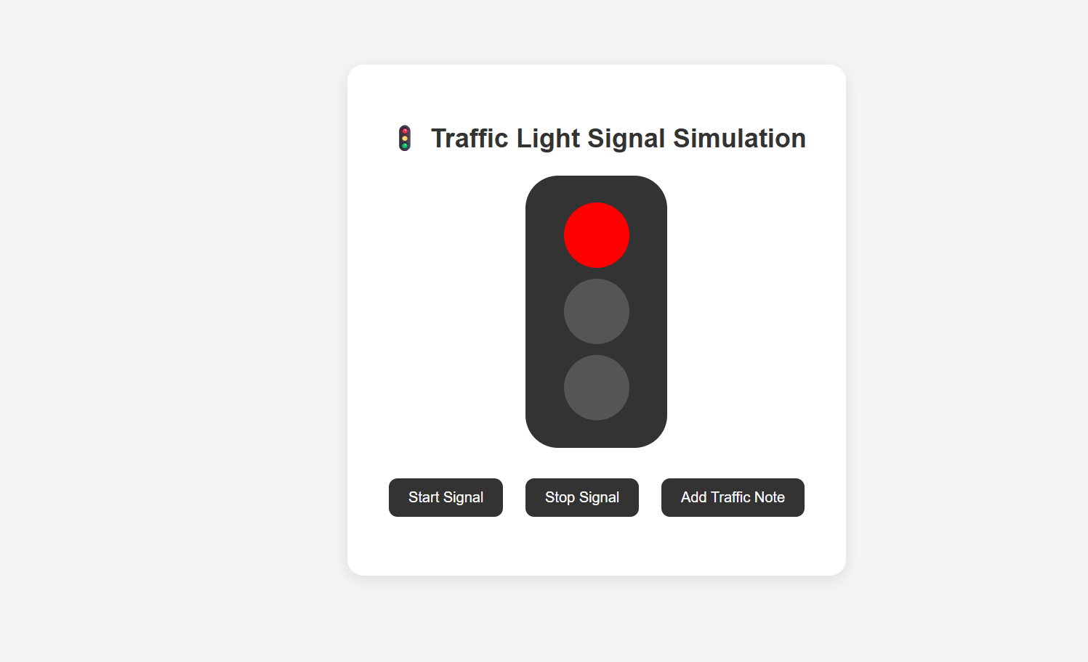
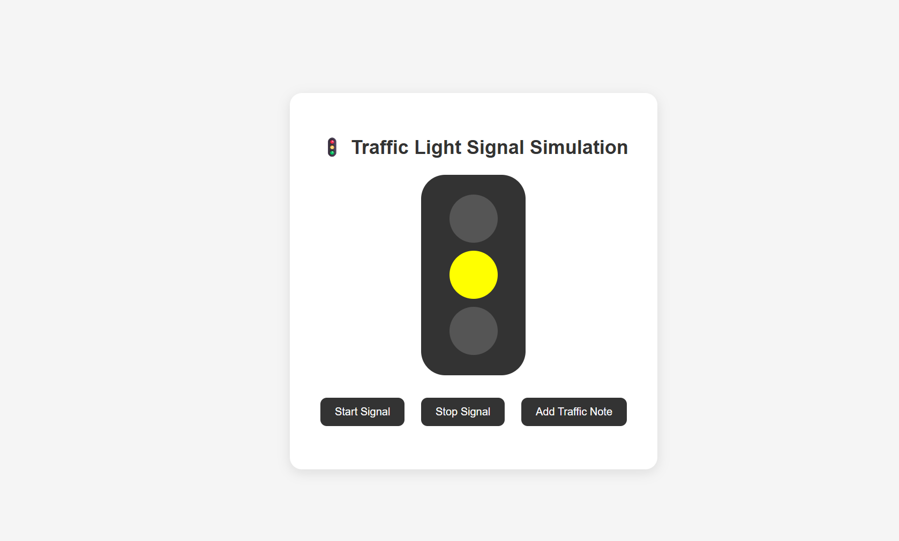
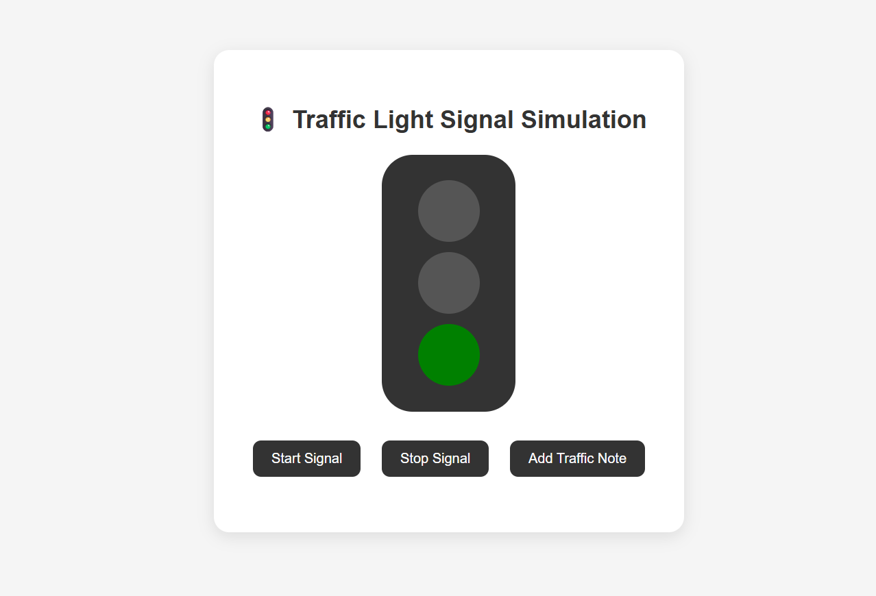
Conclusion: Hence successfully used getElementById, querySelector, createElement, and appendChild to dynamically update webpage elements.

